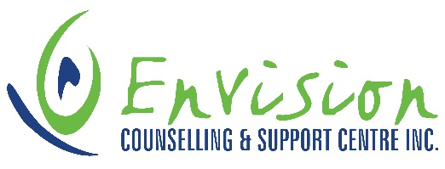

**EAP CONTRACT COUNSELLOR(S)**

We are seeking an independent contractor to provide counselling services for our Employee Assistance (EAP) and Fee for Service (FFS) Programs.

Purpose of the Position: experienced counsellor providing clinical counselling services to youth, families, couples and individuals within a short-term therapy framework. Offer EAP/FFS programming in Estevan, Weyburn and Carlyle. Flexible scheduling available including evenings and Saturdays.

**Key Responsibility Areas:**

* Provide assessment and counselling to youth, families, couples and individuals
* Make referrals to other resources where appropriate and liaise with other programs or resources around case management where necessary
* Seek appropriate consultation as necessary for clinical work
* Complete thorough, detailed and timely clinical documentation

**Qualifications:**

* Master of Social Work, Masters of Arts (Psychology), or Master of Education (Psychology)
* Five years clinical experience in the counselling field
* A member in good standing with professional governing body

CLOSING DATE: October 25, 2024

Please forward your cover letter and resume to:  
Envision Counselling and Support Centre Inc.  
Attn: Laura Melle - Director for Operations

Job Types: Part-time, Contract

Work Location: In person

Application deadline: 2024-01-31