Southeast communities among those to benefit from program’s expansion

StaffToday.ca Staff ·· Published: February 21, 2022 ·· Category: Local News
This article was posted by Estevan Mercury.

FIRST program supports families at a higher risk for violence

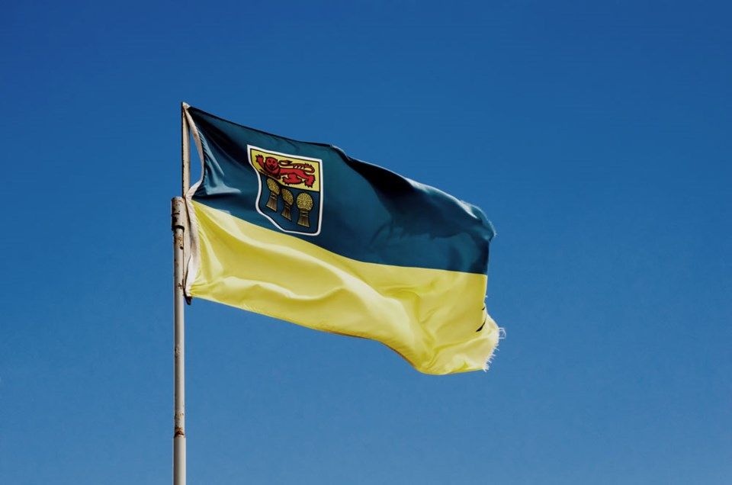
Saskatchewan FlagPhoto by Getty Images
REGINA - The Government of Saskatchewan is investing $1.1 million over the next three years to support the expansion of the Family Intervention Rapid Support Team (FIRST) program in the province.
"Enhancing community safety and the well-being of Saskatchewan families is paramount," Justice Minister and Attorney General Gordon Wyant said. "The FIRST program effectively supports families at a higher risk for violence with early intervention techniques that help to mitigate potential crisis situations at home."
The expansion of the FIRST program will see support offered to families living in the Estevan, Weyburn, Carlyle, Moose Jaw and Nipawin areas. The outreach program will be delivered by Envision Counselling and Support Centre Inc., the Moose Jaw Transition House and the North East Outreach and Support Services Inc. These groups will have trained outreach workers in place to build relationships with families in the community and intervene early to provide
collaborative and timely services to support families in crisis.
"Offering families in-the-moment support through relentless outreach encourages positive changes and a healthier lifestyle," said Envision Counselling and Support Centre executive director Lynda Rideout. "We believe building transformative relationships and providing ongoing support disrupts the cycle of violence and promotes empowerment within families ultimately leading to a healthier community as a whole."

“By taking a proactive approach, the FIRST team will build relationships and rapport within the community to identify and support families at risk,” Moose Jaw North MLA Tim Mcleod said. “The expansion of this program to Moose Jaw will not only support our community's at-risk families, but it will also help build a safer and more vibrant Saskatchewan.”
The FIRST program launched in Kindersley through the West Central Crisis and Family Support Centre Inc. in the fall of 2021.

